  The School of Technology

BSc (Hons) in Software Engineering
(Batch – 08)

Collaborative Development

(5CS024)
ROLE-BASED EVIDENCE SUBMISSION & REPORT

Student Name | Medhani Niwoda
Student ID | 2502384
Role | Project Manager

Table of Contents
1. Introduction and Role Overview 3
2. Challenges Factors and their management 3
2.1 Individual Factors 3
2.2 Team Challenges 4
3.Contributions 4
3.1.1 Jira — Sprint Board and Issue Management 4
3.1.2 Basecamp and Google Meet — Communication and Meetings 4
3.1.3 GitHub — Repository Setup and Governance 5
3.1.4 Project Management via Trello 5
4. SDLC and Agile Framework 5
5.Technical Decisions Made 6
6. Lessons Learned 6
7. Conclusion 7
8. Evidence Appendix 8
9. Preliminary Risk and Security Log 18

Introduction and Role Overview
I am currently the Project Manager for the Digital Campus Hub Project, known as Live Campus Hub, which is being built for CINEC Campus, Malabe in the 5CS024 Collaborative Development Module. My name is Medhani Niwoda. The application is currently in an active development phase and will combine many different features (GPS check-in/reward system, campus clubs directory, transit schedules, real-time facility status and dates) together in one place, on an easy-to-use web application for students.

We are using Visual Studio Code as our primary development environment; MySQL as our relational database; Node.js as our RESTful API; and HTML/CSS/JS as our UI/UX, in the development of this project. By following SDLC processes of structured, iterative software delivery and using Agile Scrum as the major method of completing the software project, we have multiple tools being used for daily communication and document management (Basecamp), version control (GitHub), sprint boards and issue tracking (Jira), and hosting team meetings (Google Meet). Sprint 1 has been focused on creating the project structure, understanding the requirements, designing the database schema, and laying out the user interface design; as well as some preliminary Node.js scaffolding back-end work.

As the Project Manager, my focus is not on writing code for production; rather, I am held accountable for managing many facets of the overall team - coordination, planning, communication, documentation, and governance - while ensuring that each sprint delivers working, tested, and documented software by the completion date. I am able to show evidence of my contributions to Sprint 1 throughout four of the tools being utilized for Agile Scrum methodologies: Jira (sprint planning and issue tracking), Basecamp (daily standups and sharing of documents), GitHub (repository management), and Google Meet (sprint kick-off and mid-sprint review).
https://github.com/Medhani77/Campus-Hub

- Challenges Factors and their management

2.1 Individual Factors

- Maintaining Authority Without Technical Role As PM I was not writing code and that made it more difficult to command credibility when making technical scheduling decisions I addressed this by taking the time to get to know the technical work so that I can have well-informed conversations.
- Tool Fragmentation The team concomitantly used Trello Jira Basecamp GitHub Excel and Google Forms The workflow of syncing the tools entailed a lot of time investment I came up with a weekly consolidation scheme that helped me update all platforms on Monday so as to reflect the same progress information. Low Google Form Completion Rates Team members did not regularly fill the weekly check-in form in the first few weeks. I decided to resolve this by ensuring that it is an agenda item during each stand-up session and contacting non-respondents individually.

2.2 Team Challenges
- In even Distribution The team also had certain problems of assignment during the first steps of the sprint, as not all team members were able to finish their tasks within the time frame as some of them did in a very short time. I utilized the Jira velocity report to bring this to the surface and redistributed tasks during the mid-sprint review. The Scope Creep Pressure Team members kept on arguing to add new features that were not on the agreed scope of MVP e.g. the Marketplace and Careers module and I kept the scope boundary intact by documenting all the suggestions therein the Jira backlog and putting them in Sprint 2 on record.
- Integration The frontend and backend teams were not exchanging their API requirements, so it resulted in integration failures in the final sprint. A particular API contract meeting was facilitated by me when I had written down the sharing field names in a Basecamp document.

3.Contributions

3.1.1 Jira — Sprint Board and Issue Management

Before we started with Sprint 1, I created the Live Campus Hub project and created/configured the Jira board for Live Campus Hub. I also created the first sprint called Sprint 1 on the Jira board that included all User Stories from our Product Backlog. For each User Story, I created work and subtasks, assigned each work/subtask to the team member responsible, assigned a Prioritization Level of High, Medium, or Low, and estimated Story Points for each User Story.

I updated the project in Jira each day by updating work status, monitoring tasks that were blocking the completion of work, and documenting any blocking task with comments on the corresponding ticket. I noticed that a dependency existed between the MySQL schema and HTML forms. I established and formally assigned a linked issue to Udara Nethmi and Pulindu Balasooriya using the Jira Board. In conjunction with the Jira Board, I developed an Excel-based role-based tracking sheet that I shared with the team via Basecamp so the team could see the overall status of the project.

3.1.2 Basecamp and Google Meet — Communication and Meetings
Basecamp is the primary platform used by the team for asynchronous communication. I set up a Live Campus Hub project on Basecamp and invited all five team members to participate, with the expectation of posting a progress update each day. Each progress update provided a format for each team member to give the status of what was completed; what was blocking; what is planned to be completed. The cumulative progress posts acted as our daily asynchronous standup meeting and created a historical record of team activity throughout Sprint 1.

In addition to Basecamp, I also set up two Google Meet meetings during Sprint 1. The initial meeting was to kick off Sprint 1 where we reviewed the project brief and agreed on the Definition of Done. We also walked through the product backlog, assigned user stories and confirmed the technology stack. The second meeting was a mid-sprint review where I facilitated a review of progress and helped to resolve an issue of scope - one team member had started the development of a feature that was planned for Sprint 3. I was able to redirect that effort to bring it back within the Sprint boundary. Both meetings had full attendance of all six members.

3.1.3 GitHub — Repository Setup and Governance
I created a GitHub repository under my profile, https://github.com/Medhani77/Campus-Hub. I created a 3-tiered branch strategy of a protected main branch for stable releases, dev branch for integration, and feature branches for each member on the team (For example: feature/login-UI, feature/DB-schema, feature/node-auth). Each of the 5 members on the team was added as a Collaborator with Write access and confirmed that they had accepted their invitation before the beginning of Sprint 1 development.

The README.md file was authored by me and committed to the main branch. This document provides project purpose, technology stack; VS Code, HTML/CSS/JS, Node.js, MySQL; Agile sprint plan by 5 sprints; Database overview; API Endpoint reference and all members of team with student id and roles. This document will provide any reviewer who opens the repository with a professional and proper entry point.

3.1.4 Project Management via Trello
The Project Manager created and managed the team board of the Campus Hub Project Trello board and sorted out the tasks according to the columns, as the real-time development status was shown in the five columns: Backlog, To Do, Testing, Done, and Bugs. Student Registration Feature, Notification System, Library System, Rewards System, and Events are some of the main tasks that can be seen on the board under the Key Tasks, whereas Design Cafe Page and MVP Report are some tasks that can be found under the To Do list; Test Student Registration, Check Database Data Saving, and UI Responsiveness Testing are under the Tests column, and the final Dashboard and Done are under the Done. Due dates and checklists were attached to each card to make the team members accountable and track the progress, which proved my active contribution to the coordination of the team and the project life-cycle in accordance with the industry-standard practices demanded by 5CS024.

4. SDLC and Agile Framework
As a team, we are using both the Agility Scrum and the SDLC framework. We have completed two phases of the SDLC from the beginning of Sprint 1 through the completion of requirements and design; gathering all of our functional requirements based on the project brief, producing UML class diagrams, producing an ERD (Entity Relationship Diagram) as well as creating an Agile flowchart to outline our five-sprint delivery cycle. All these documents (along with some additional documentation) are available in the formal repository under the /docs folder and have been distributed via Basecamp to the team for review.

Moving forward, we will work through the remaining phases of the SDLC (implementation during Sprints 2, 3 and 4 & testing and deployment during Sprint 5) while utilizing Agile sprints to provide us with an iterative structure throughout the remaining waterfall stages of the SDLC. This will allow us to continue to be flexible in our development while providing a structured and disciplined process for delivering our results.

5.Technical Decisions Made
While my major responsibilities are primarily at the leadership level, I was instrumental in transforming multiple key technical decisions throughout sprint 1. The largest action taken was leading the team through an agreement to consider our technology stack; VS Code (VS Code), HTML/CSS/JavaScript (HTML; CSS; JavaScript), Node.js with Express (Node.js + Express), and MySQL (MySQL). This was performed through a team-based decision during the kick-off Google Meet and documented as a formal decision ticket in Jira so all team members can see what has been decided to date. This technology stack was selected for its ability to leverage a standardized JavaScript Development Model, the skillset of the current team, and the ability to use a relational database.

I enforced a schema-first development methodology, which required that Udara complete all-required MySQL CREATE TABLEs before undergoing any front-end development. This asynchronous dependent working agreement was also created as this would provide a formal means through which to maintain the required sequence of connections. The schema is for 13 different tables, comprising students; locations; check-in; campus event; transit routes; clubs; reward; redemption; notification.

Additionally, we decided to use JWT for authentication and to use bcrypt to encrypt user passwords in the MySQL database. These industry-standard practices support overall BCS data protection requirements.

6. Lessons Learned
Having completed the first sprint, I am now able to understand, in detail and practically, the process of project management involved throughout the course of developing a software application using a collaborative development team. One of the most significant insights I gained from Sprint 1 was the importance of making the management of dependencies explicit and formal. For example, I captured the MySQL-to-HTML dependency in Jira as an associated issue linking the dependency to the project itself. By being explicit about the dependency in Jira, it was now more easily visible and could be tracked more readily.

For Sprint 2, I will also create a dependency map during our sprint planning phases so that the sequencing constraints will be agreed upon by everyone involved before any coding begins. Also, I learned through this first sprint that while both Jira and Basecamp serve different purposes, they each serve to complement each other (with Jira providing precision with regard to task completion (e.g.: task status, story points, blockers, burndown), and Basecamp providing visibility in human-readable format (e.g.: daily updates, shared documents). When I used both systems together, I was able to gain a complete picture of the health of my last sprint.
The final major insight from Sprint 1 was regarding the enforcement of scope. When one of my development team members started to work on a feature scheduled for Sprint 3, I was able to use the Jira board to very quickly identify it as being completed in the wrong column in Jira. As a result, I was able to react quickly, bring it up at the next mid-sprint Google Meet and modify Jira to reflect the corrections that needed to be made with respect to task assignments.

In conclusion, I have learned that writing documentation forms a part of any technical contribution. Creating the README file, writing a project proposal and keeping track via an Excel document required me to have a solid understanding of all areas of the project at hand. All of these documents already serve as a valuable source of reference and will continue to be important as complexity increases throughout Sprints 2 to 5 of this project.

7. Conclusion
The Live Campus Hub is built on solid groundwork provided by Sprint 1 which will help us develop a stable product. As the Project Manager of this initiative, I am able to provide you with numerous examples where I made a direct contribution to the overall success of this project. Some of my contributions were via maintaining and managing the Jira sprint board, maintaining status through the Basecamp communication board, providing meeting functionality through two (2) Google Meet meetings, establishing and maintaining the GitHub repository which contains the source code, and writing and maintaining the project README and proposal. There is documentation to support every contribution noted above in Part 2 of this submission.

I believe that the Agile/SDLC framework we have established with the help of Jira, Basecamp, GitHub, and Google Meet will allow for continued growth of our team during Sprints 2 to 5 in a very efficient manner. My primary objective for Sprint 2 is the completion of the check-in and rewards engine, along with ensuring that the Node.js API integrates seamlessly with the MySQL database.

MVP Video:-
https://drive.google.com/drive/folders/1m4RgOz87aQRCz4njhCxIE4ueHcoR8xuJ?usp=sharing

Evidence Appendix

1.Jira Sprint Board (Sprint 1 Setup by PM)
Item Type | Jira — Sprint 1 board created and managed by Medhani Niwoda (PM)
Description | Jira project created for Live Campus Hub. Sprint 1 board configured with all user stories, tasks assigned per role, priority levels (High/Medium/Low), and story point estimates. Board monitored daily by PM — statuses updated, blockers flagged as Jira comments.
Evidence | 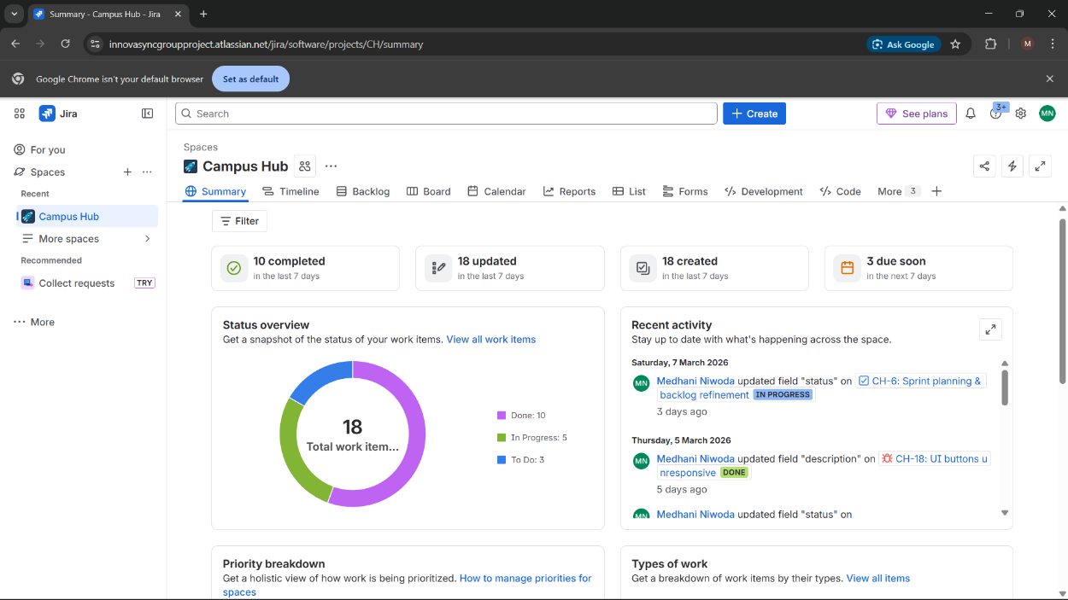  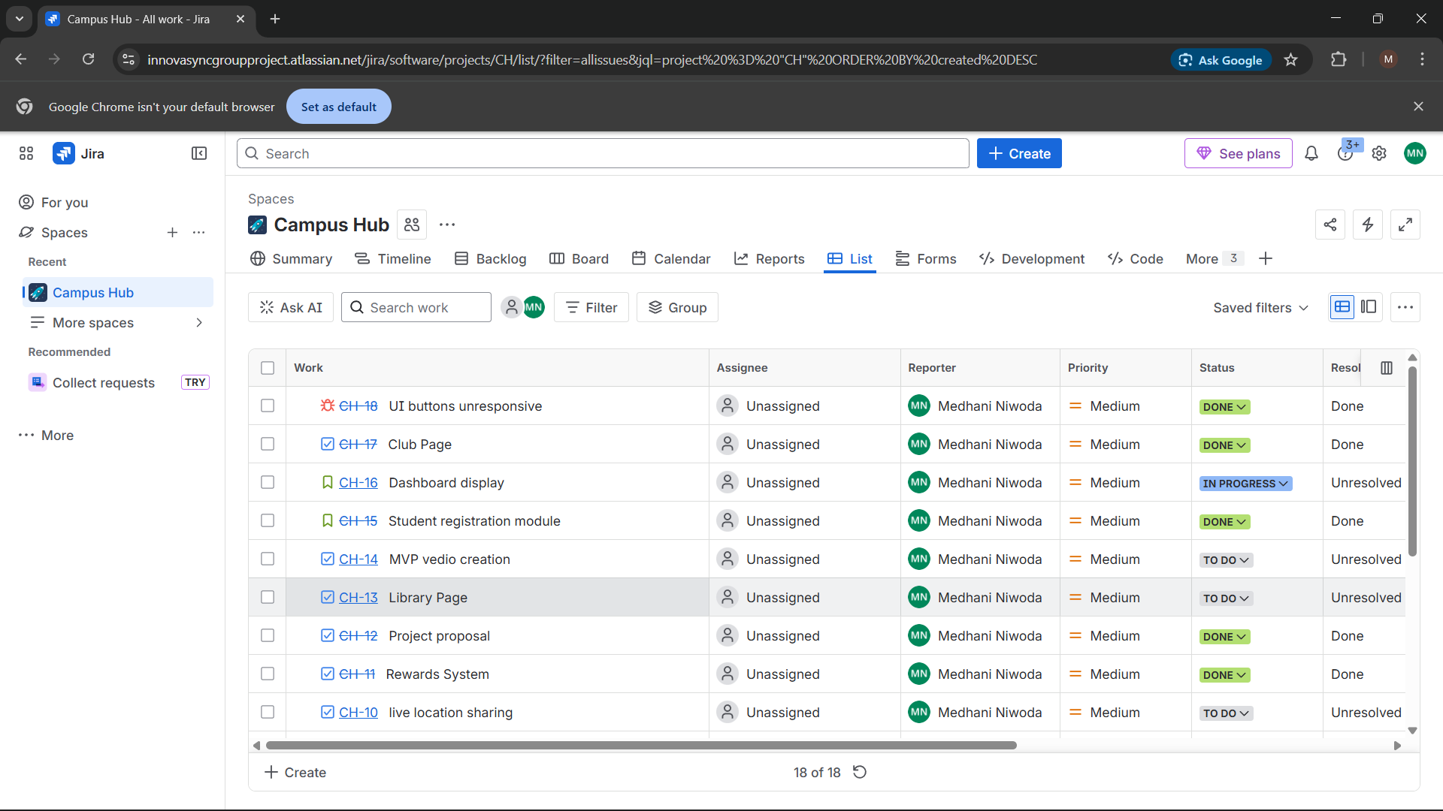
2.Basecamp Daily Update Posts
Item Type | Basecamp message board — daily standup posts
Description | Team expected to post daily: tasks completed, blockers, and next steps. I posted PM updates and responded to team queries throughout Sprint 1. Basecamp also used to share all project documents.
Evidence | 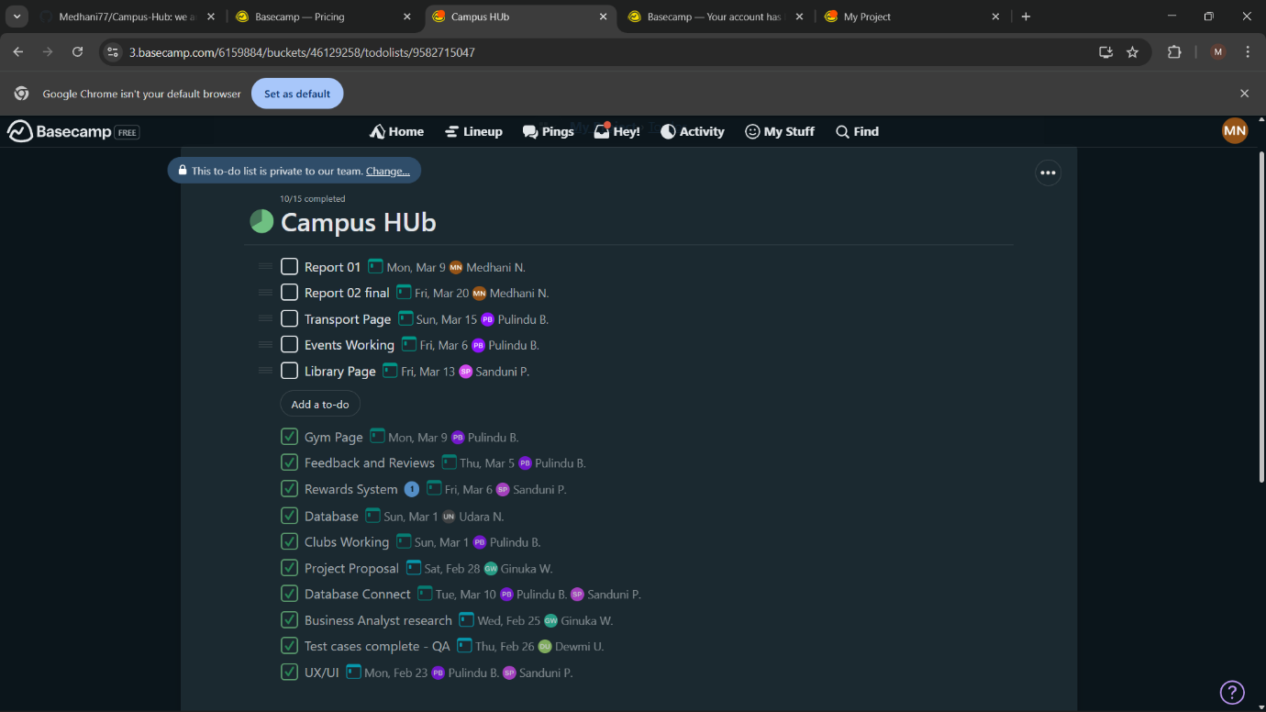  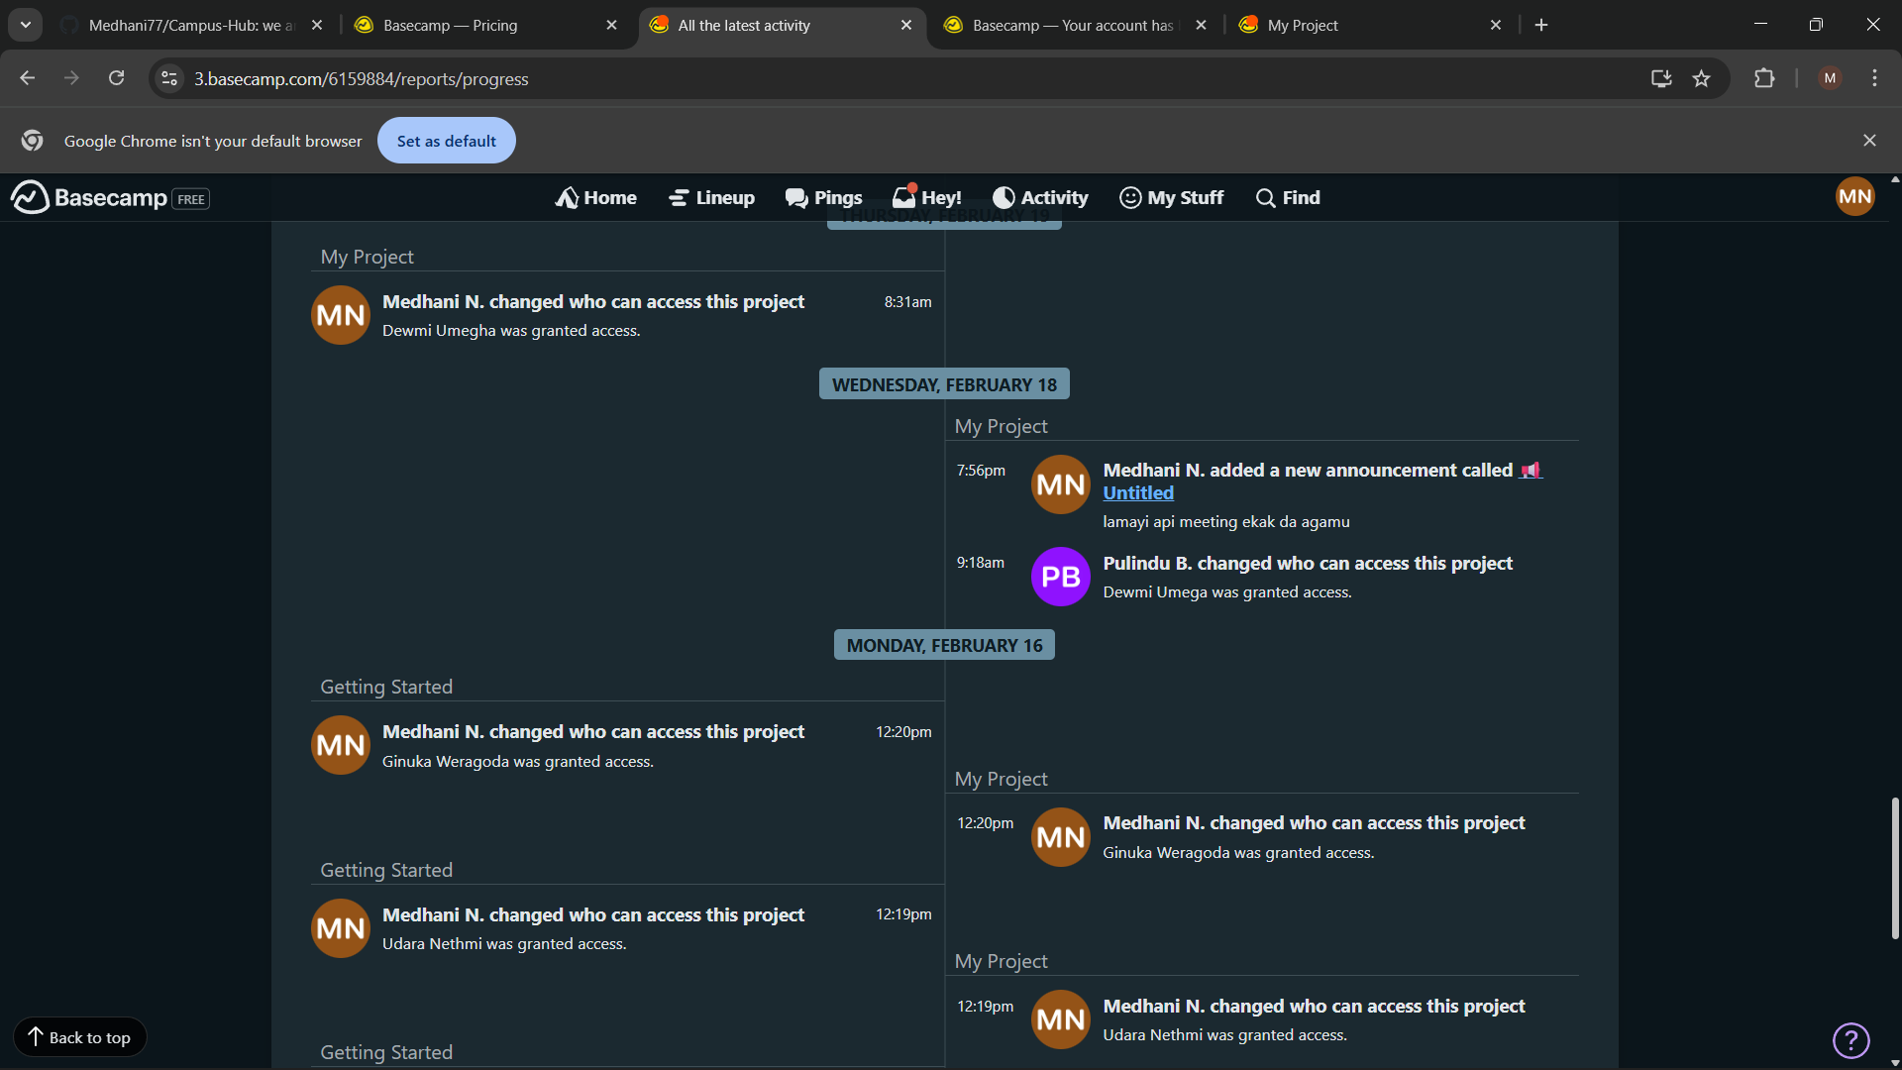

3.Basecamp Project Documents Shared

Item Type | Basecamp file uploads — shared project documents
Files Shared | Project Proposal (.docx), MySQL schema (.SQL), UML Class Diagram (.png), ERD (.png), Agile Flowchart (.png), Sprint 1 Excel tracker (.xlsx). Jira board link also shared via Basecamp for full task visibility.
Evidence | 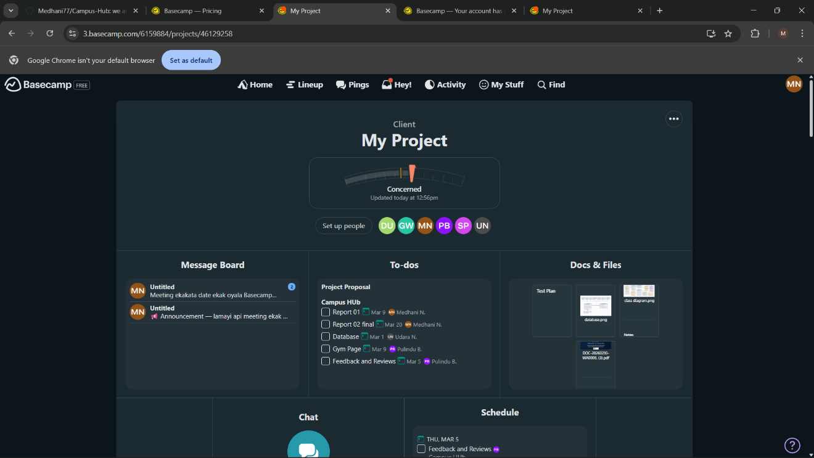  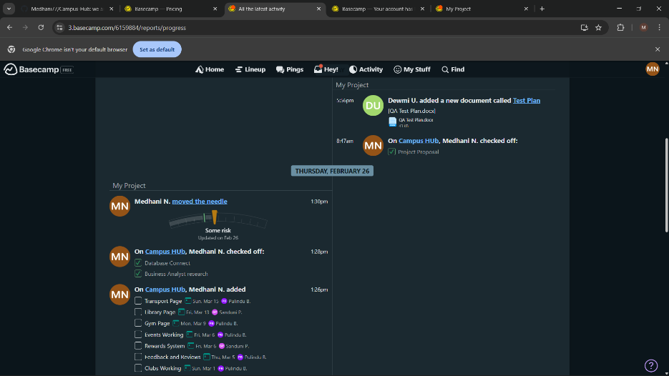

4.Google Meet — Sprint 1

Item Type | Google Meet video call — all 6 members present
Agenda | Backlog review, task allocation, Definition of Done, tech stack confirmation (VS Code / Node.js / MySQL), branching strategy walkthrough.
Evidence | 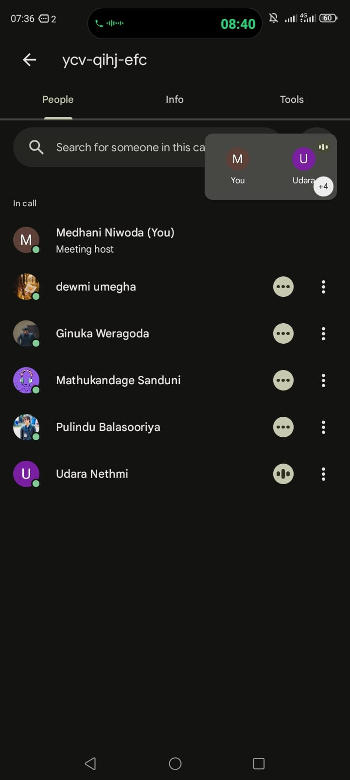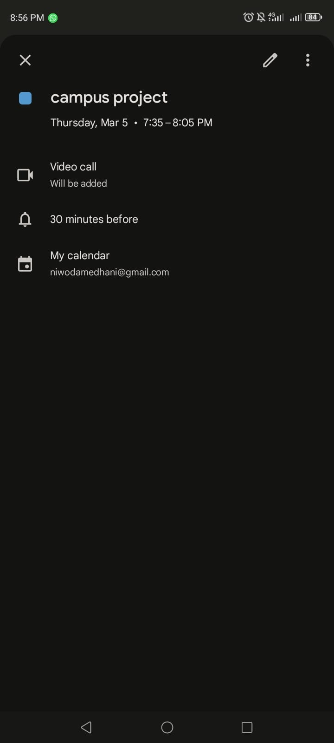

5.Excel Sprint Tracker
Item Type | Excel spreadsheet — role-by-role task tracker
Description | Created at Sprint 1 start. Columns: Task Name, Assigned To, Status (Not Started/In Progress/Complete), Due Date, Notes. Updated daily and shared via Basecamp.  PM_Gantt_Dashboard_10_Weeks_Roles (1).xlsx
Evidence | 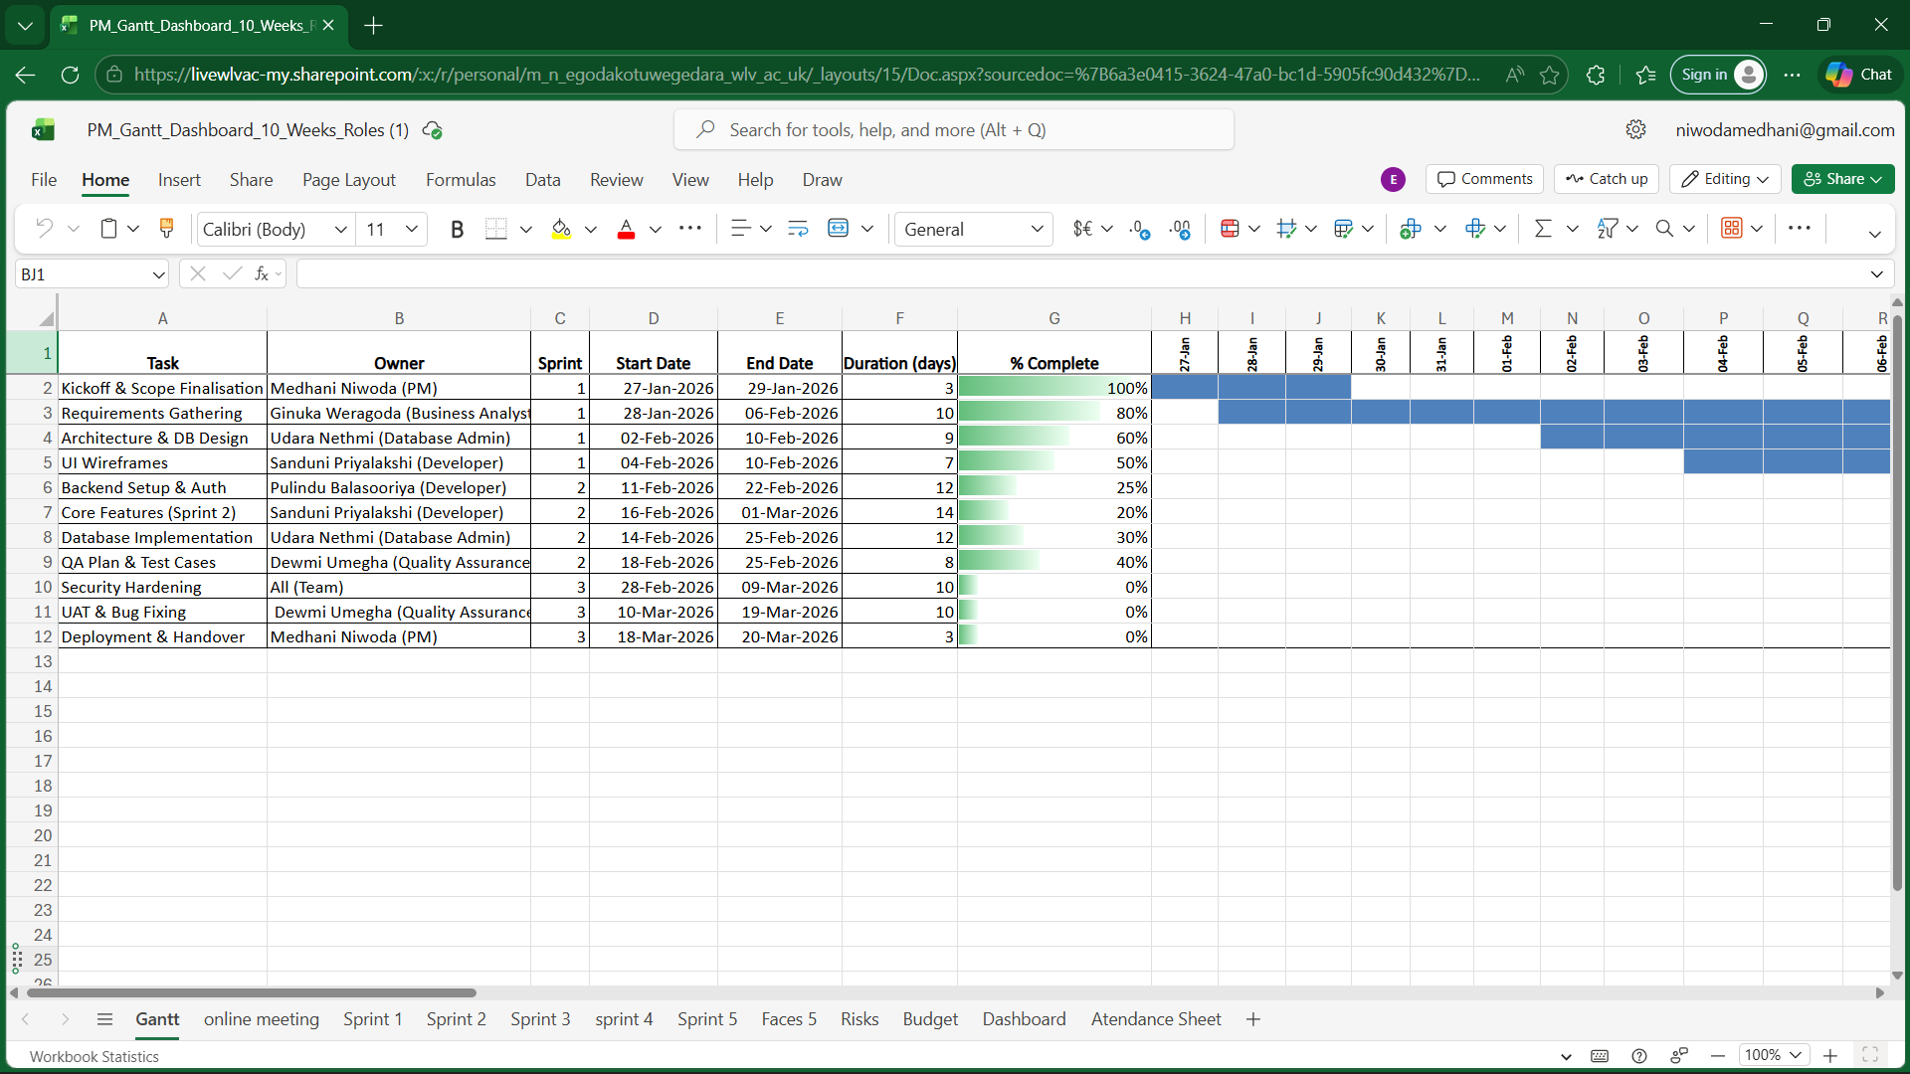
6.GitHub README.md (Authored and Committed by Medhani Niwoda)
Item Type | GitHub README.md — authored and committed by PM
Content | Project description, tech stack (VS Code/HTML/CSS/JS/Node.js/MySQL), setup guide, DB overview (13 tables), API endpoints, Agile sprint plan, full team table.
Evidence | 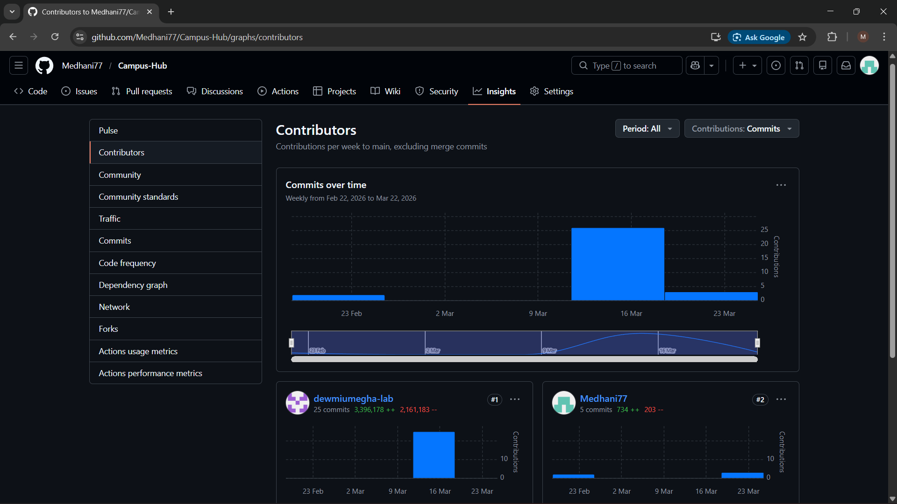  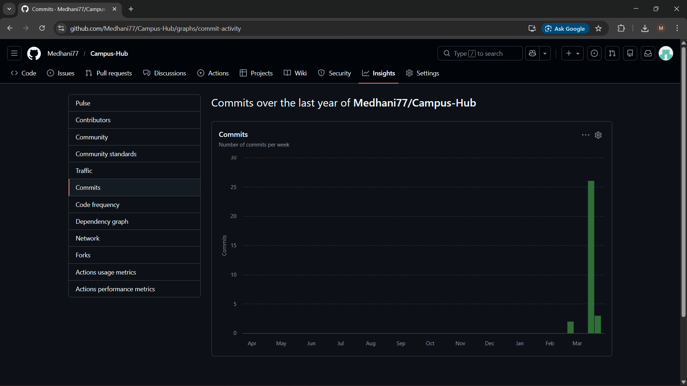  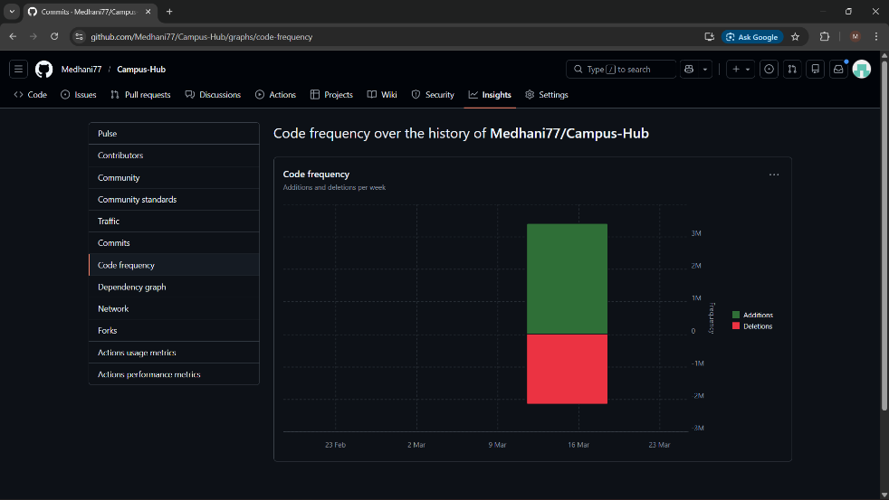  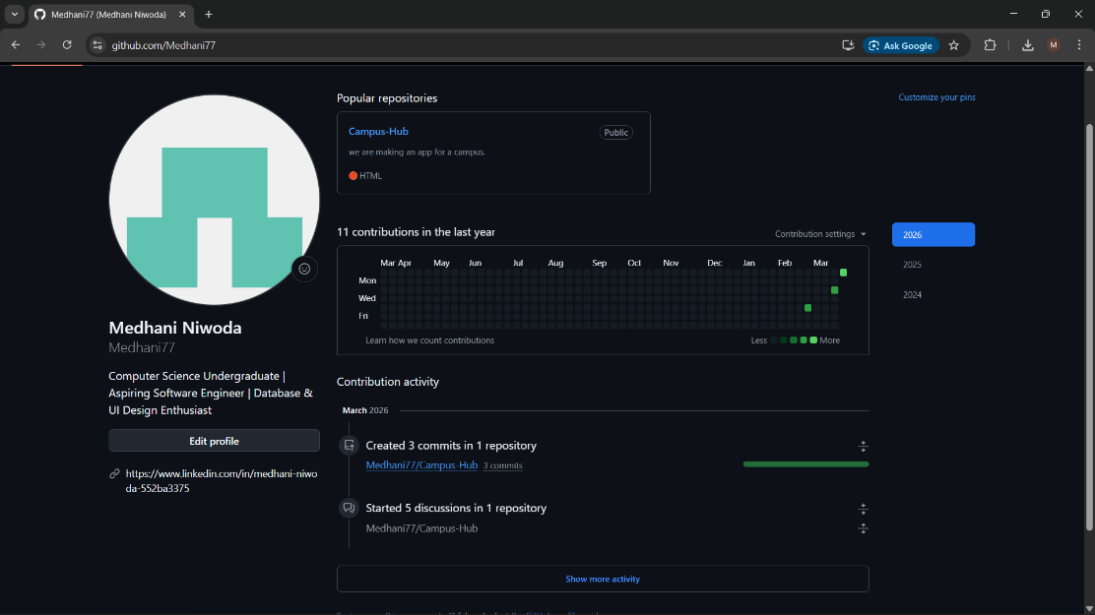  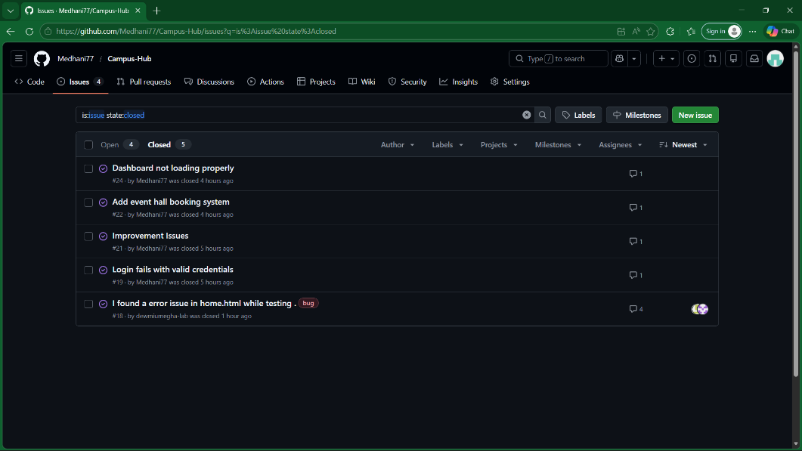  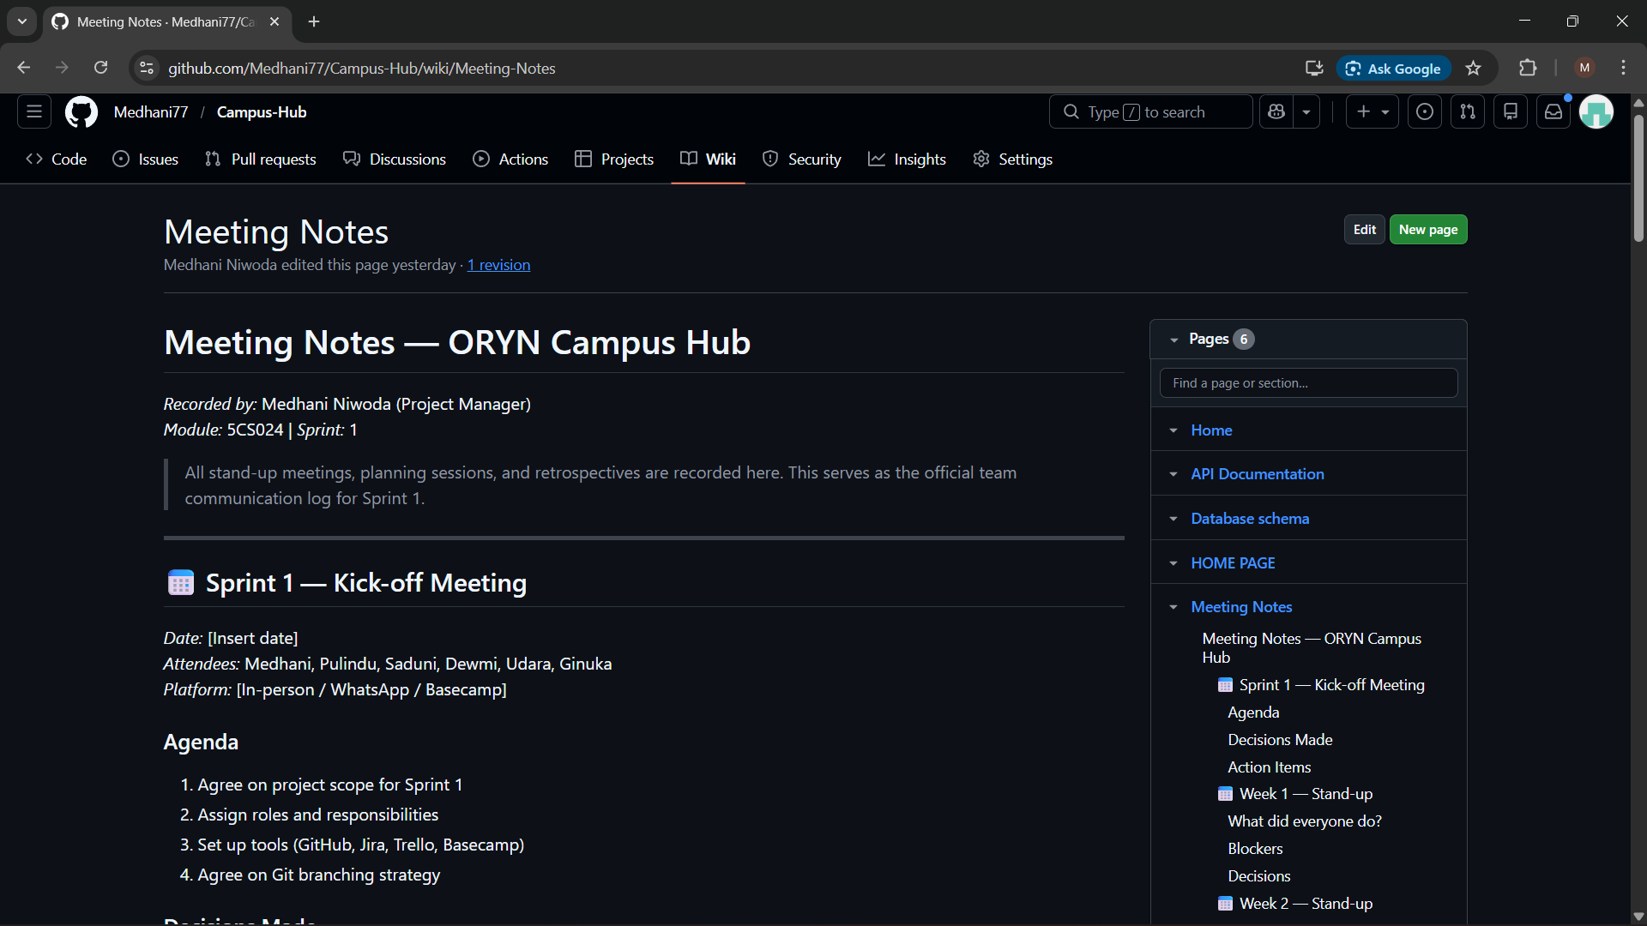  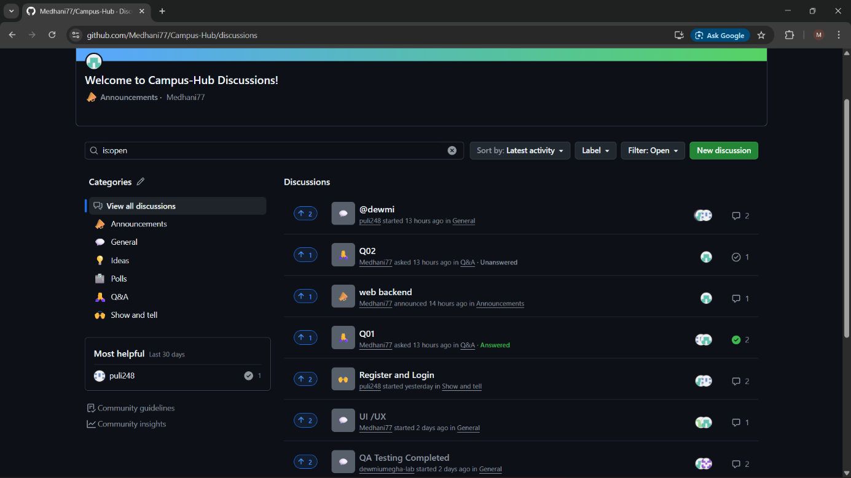  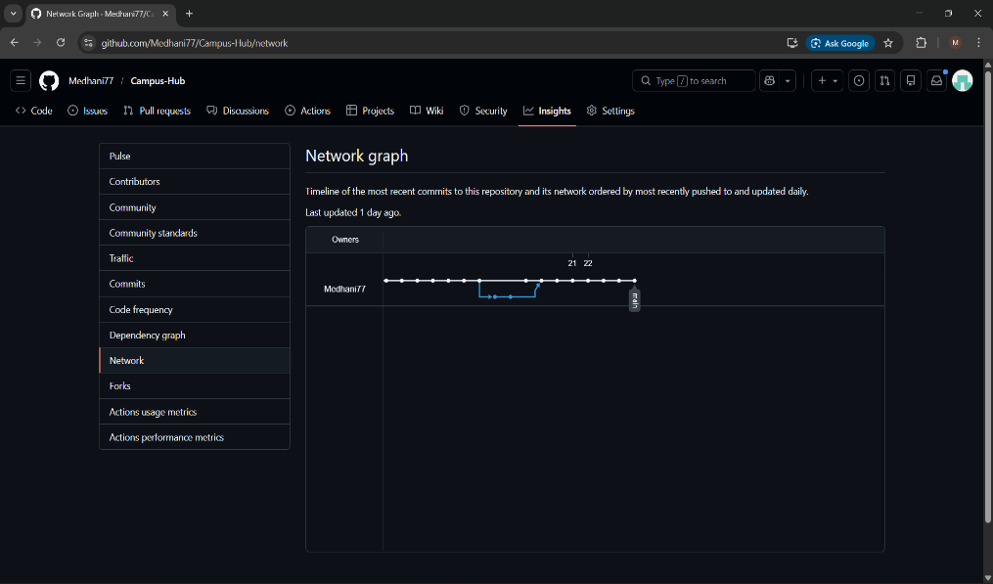  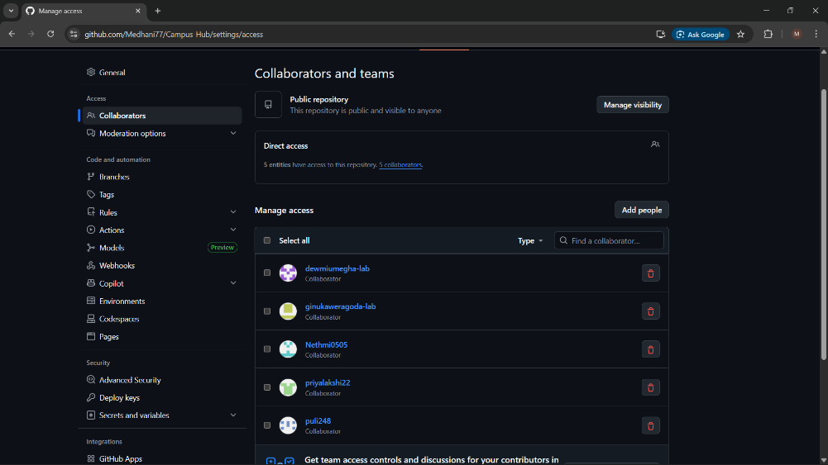  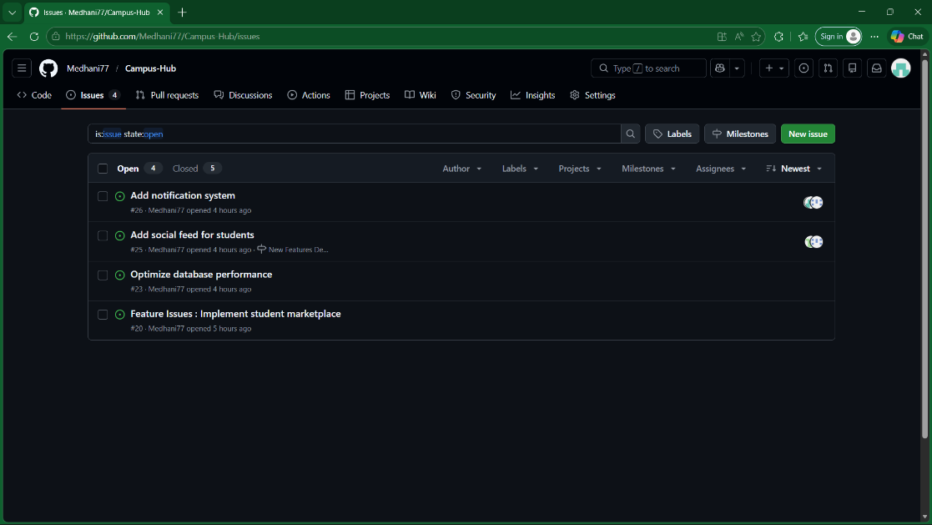

7. Project Management via Trello

Item Type | Projects Updates
Content | Backlog, To Do, Testing, Done, and Bugs.
Evidence | 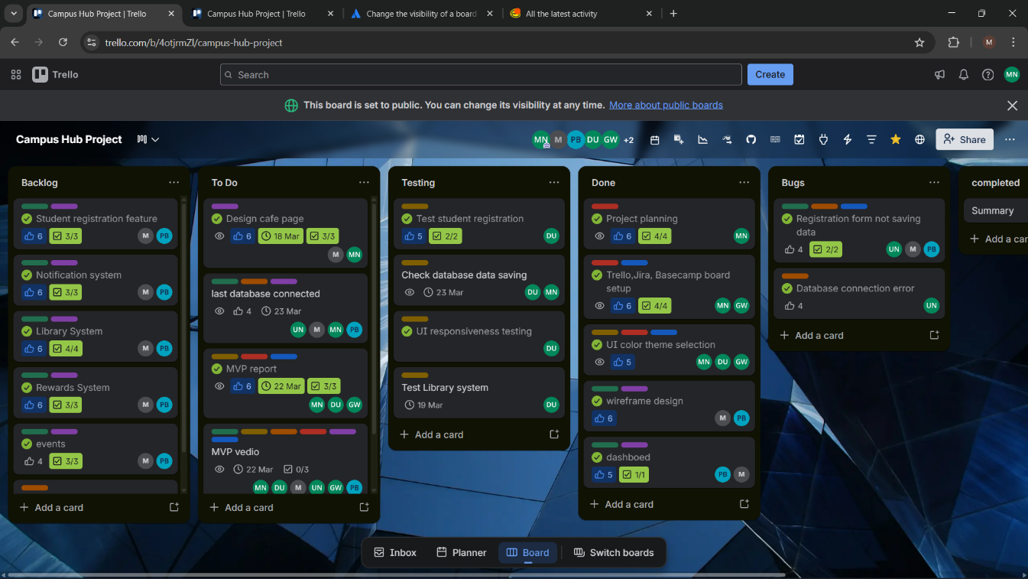  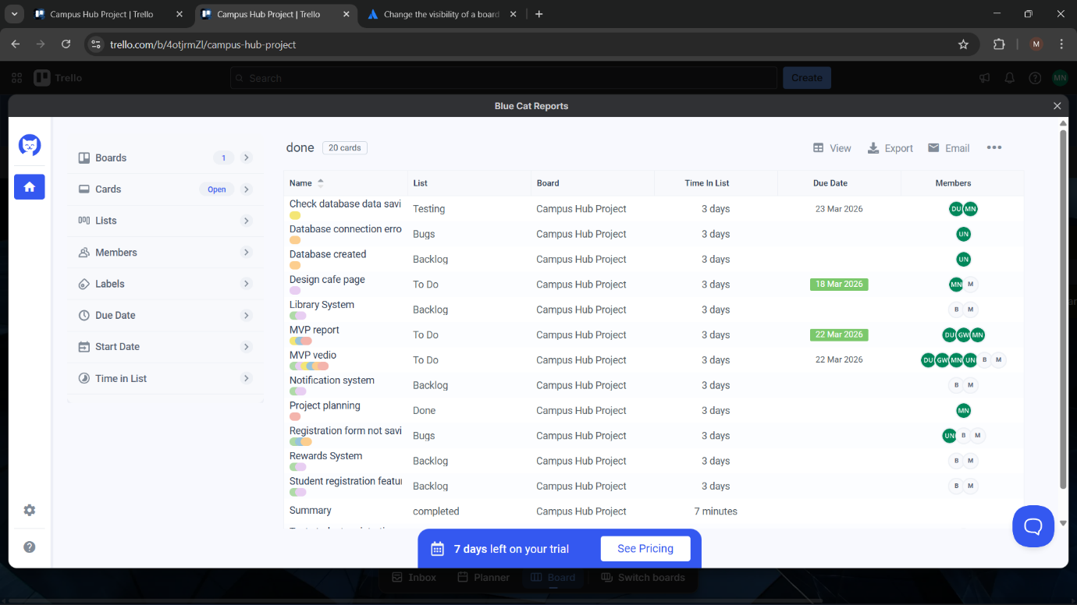

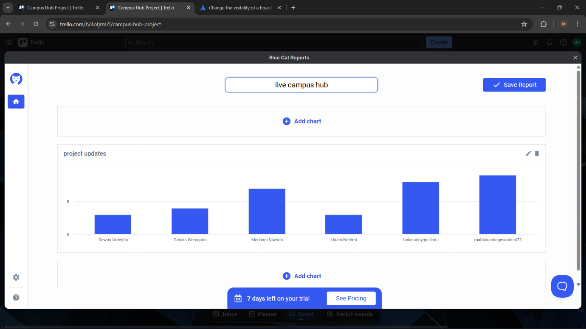

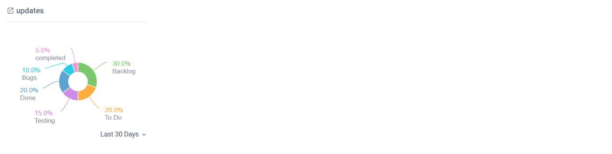
8. Project Management via Google Form
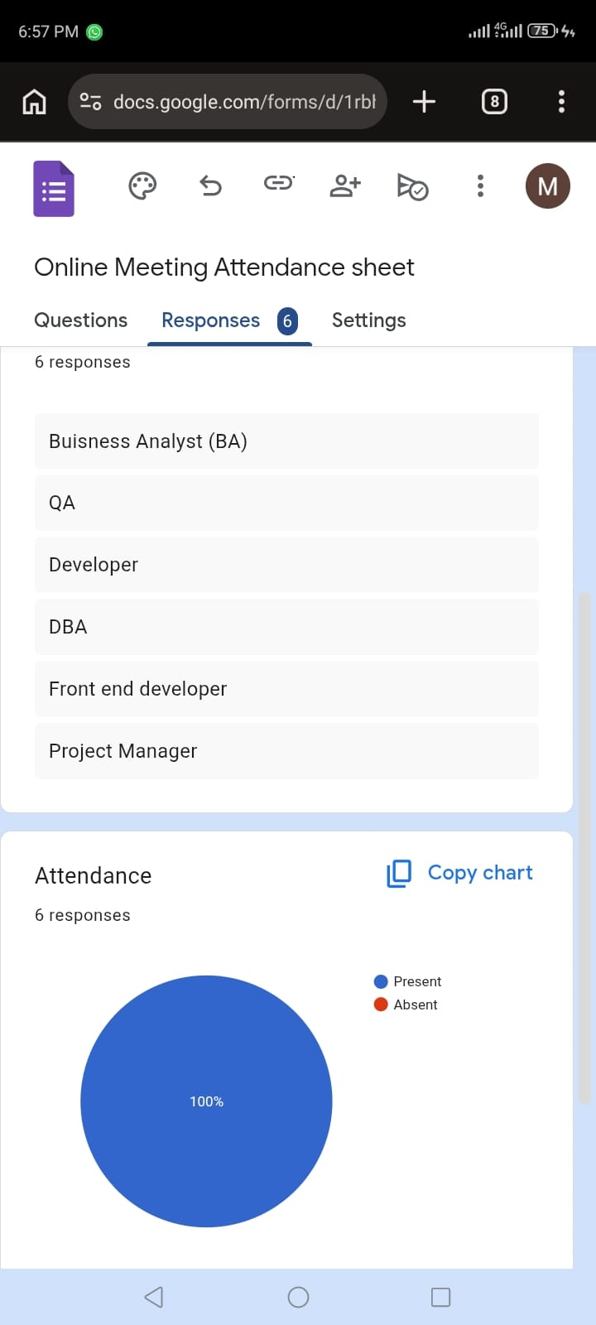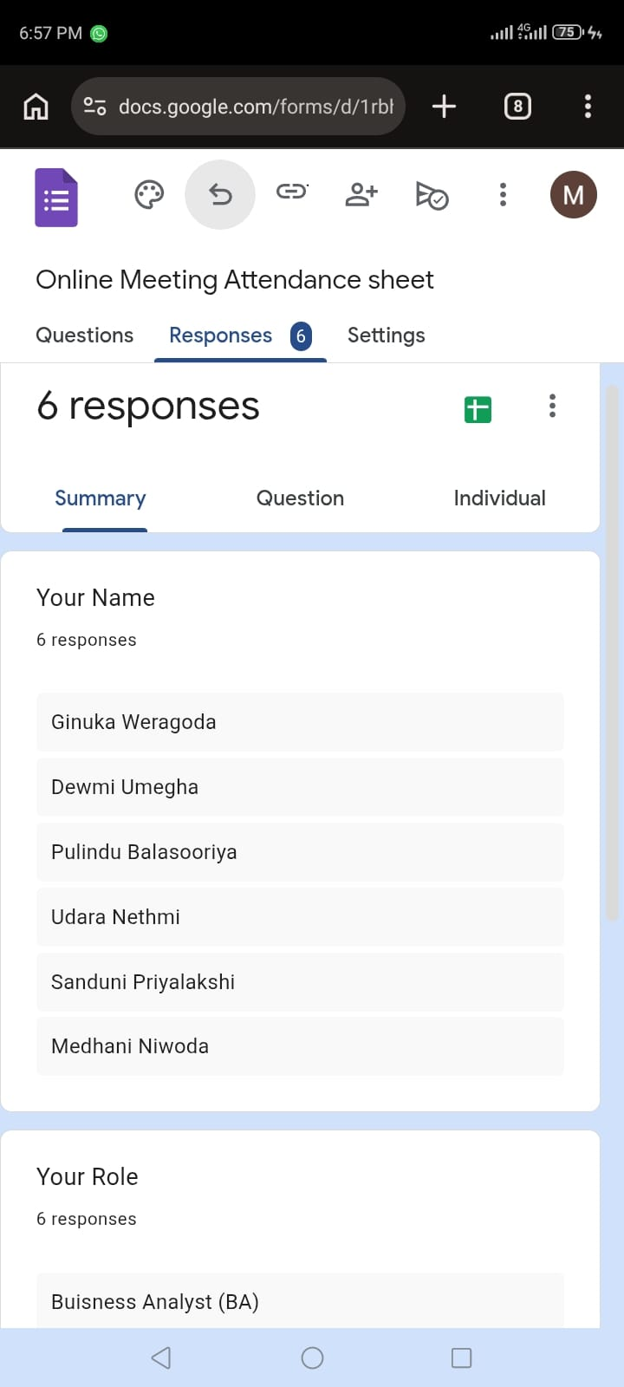
- Emails

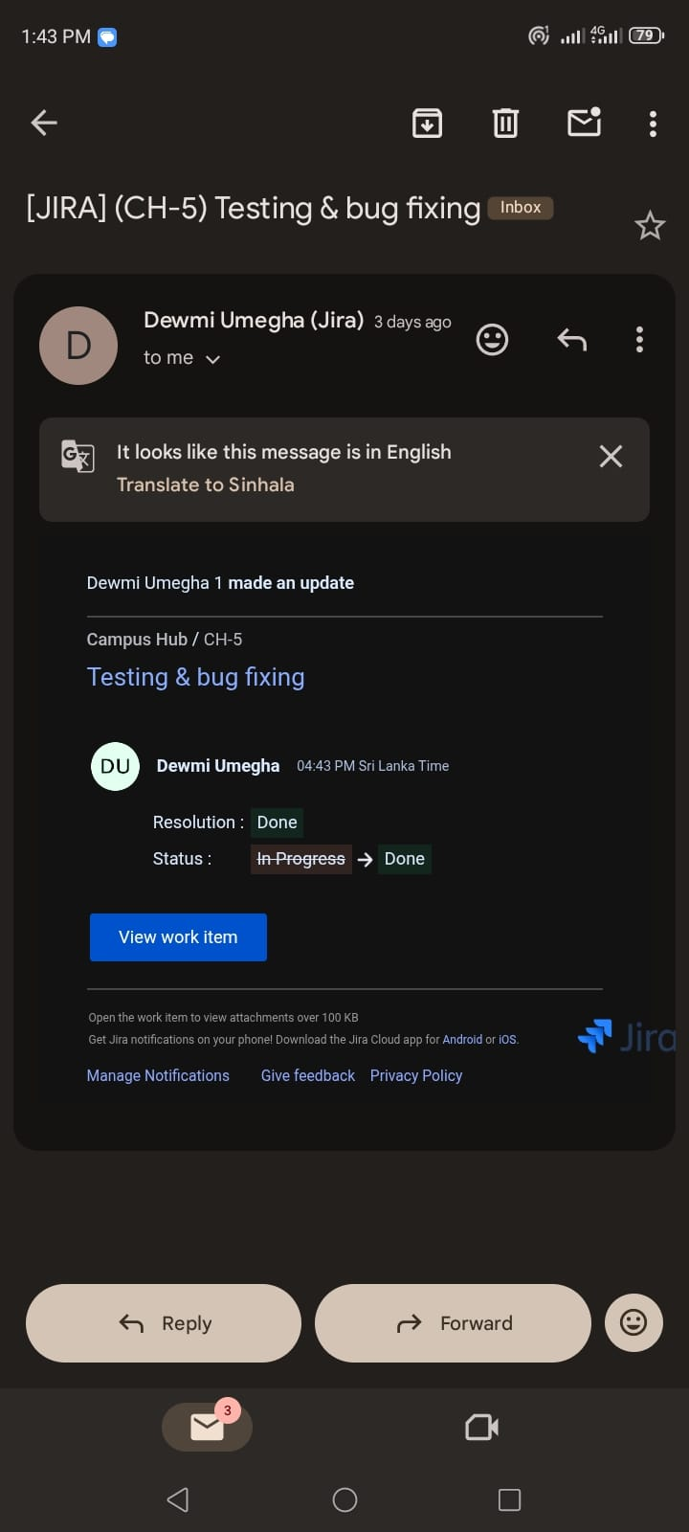
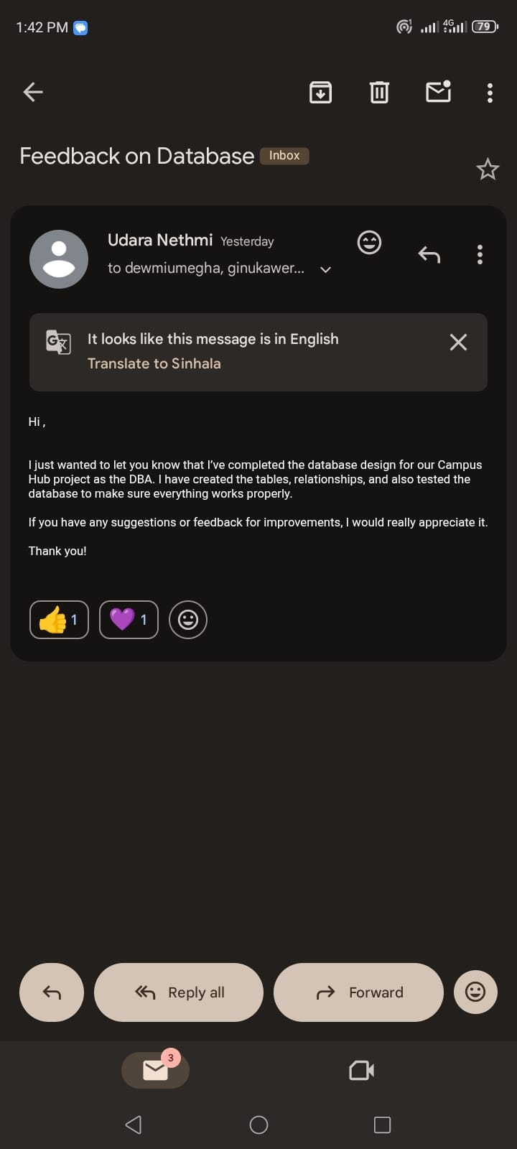

Preliminary Risk and Security Log
Part 1: Risk Assessment Key

Score | Likelihood (1–5) | Impact (1–5)
1–4 | Low: Keep under review. | Minor: Inconvenient but not critical.
5–12 | Medium: Needs a plan. | Moderate: Requires changes to design/code.
15–25 | High/Extreme: Urgent action required. | Catastrophic: Project failure / Data Breach.

Part 2: Risk Register — PM Role Specific Risks

Ref ID | Risk Category | Risk Description / Threat | Likelihood (1–5) | Impact (1–5) | Total Score (L x I) | Proposed Mitigation for Sprint 2
R01 | Schedule | Team member submits Sprint 2 work late — causing the check-in or rewards feature to be incomplete at sprint review | 3 | 4 | 12 — Medium | Daily Basecamp check-ins flag delays within 24 hours. Excel tracker reviewed each morning. PM escalates and reallocates tasks if any item is 2+ days overdue. Mid-sprint Google Meet confirms progress against plan.
R02 | Technical | Node.js API fails to connect correctly to MySQL database — blocking frontend UI from displaying live data | 3 | 5 | 15 — High | Database connection tested in isolation before frontend integration. Connection string stored in .env file (not hardcoded). Udara and Pulindu to do a joint integration test at the start of Sprint 2 before new features are built.
R03 | Security | Student passwords or database credentials accidentally committed to GitHub repository in plain text | 2 | 5 | 10 — Medium | .env file added to .gitignore from Sprint 1. All team members briefed: no credentials in code. PM to scan repository for exposed secrets before each sprint review using GitHub secret scanning. bcrypt used for all passwords in MySQL.
R04 | Team | Merge conflicts on GitHub — two developers edit the same HTML or Node.js file simultaneously, breaking the integration branch | 4 | 3 | 12 — Medium | Enforced feature branch strategy — no direct commits to dev or main. All merges via Pull Request reviewed by PM before merge. Team members instructed to pull latest dev before starting each session. PM monitors open PRs daily.
R05 | Schedule | Scope creep — features planned for Sprint 3/4 (social feed, notifications) are started in Sprint 2, leaving core check-in and rewards work incomplete | 3 | 3 | 9 — Medium | Sprint backlog reviewed at every standup and Google Meet. Any out-of-scope work is immediately moved to a future sprint backlog item on Basecamp. PM enforces sprint boundaries strictly — occurred once in Sprint 1, resolved in mid-sprint review.

